Johnny Li

EEL3111C

Tuesday P.10-11

Lab 7-Write Up

Introduction

The goal of this lab is to explore capacitor, and their applications within different circuits. The 555timer component was used to test how resistors and capacitors effect pulse duration and period of a circuit. A physical board was built to analyze the derivations from the ideal and physical circuit design.

Discussion

7.6.1 Construction

The output voltage and capacitor voltage

Figure 1: The output voltage and capacitor voltage of circuit from Section 7.5.2 Item 2. Set Vcc to 5 V supply and use a 5 kHz square wave as the input with a 2.5 V amplitude and a 2.5 V offset.

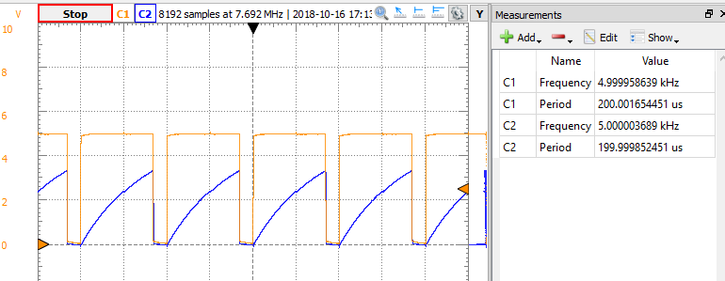

Figure 2: The output voltage and capacitor voltage of circuit from circuit from Section 7.5.1 Item 3. The output pulse duration is approximately 200μs for a 100 kHz input.

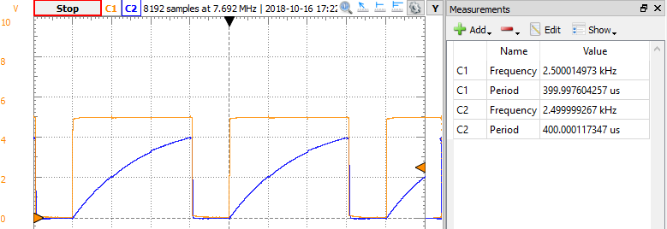

Figure 3: The output voltage and capacitor voltage of circuit from circuit from Section 7.5.1 Item 4. When RA=10k, RB=10k, and CL=0.01μF.

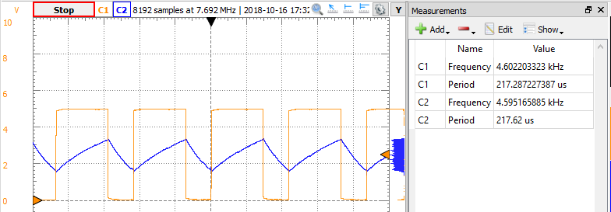

Figure 4: The output voltage and capacitor voltage of circuit from circuit from Section 7.5.1 Item 5. The output pulses are about 10 kHz.

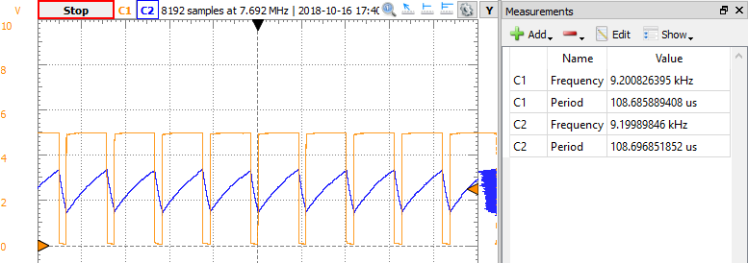

Table 1: Tabled experimental periods for the output voltages and percent error when compared to the theoretical values in the pre-lab.

|  |  |  |
| --- | --- | --- |
| Table 1: Output voltage period of physical circuit design | | |
| Circuit Configurations | Output Voltage Period (μs) | Percent Error (%) |
| 2. Mono-stable | 200.0017 μs | 4.7 % |
| 3. Mono-stable | 399.9976 μs | 0.0006 % |
| 4. A-stable | 217.2872 μs | 0.006 % |
| 5. A-stable | 108.6969 μs | 16.4 % |

The values from the physical circuit designs were calculated in lab where there exist deviations in the output voltage period that causes the percent errors. It should be noted that the percent error for item 3 and 4 are extremely low and can be round to the value of zero. The percent error for item 2 is within the 5% boundary, therefore it is a reasonable expected value. The final percent error for item 5 is relatively high because the chosen RA, RB, and CL values were incorrect in the prelab thus skewing the theoretical output voltage period for comparison.

The reasons for the percent errors on the circuits is due to the variations of the combination of resistor tolerances, capacitor quality, and the internal resistance on the scope probes. The scope probes do indeed adversely affect the circuit.

Conclusion

In the end, the probes, capacitor and the resistors affect the period and pulse duration in the physical circuit design. A large capacitor will produce a longer period and pulse duration because it takes longer for the capacitor to reach capacitance. Resistors affect the period and pulse duration by fluctuating the voltages due to the resistor tolerance.